HEANEY-MIŁOSZ RESIDENCY
Application Form 2022
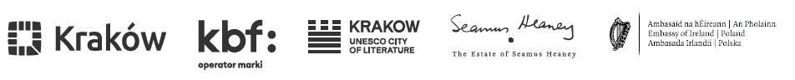

Personal Information

Full Name:

Date and Place of Birth:

E-Mail Address:

Telephone Number:

Full Address in Ireland:

Profession (Writer, Poet, Journalist, Other):

___________________________________________________________________________

Please outline why a Residency in Krakow would be beneficial for the development of your writing at this time. (Max. 350 words)

…………………………………………………………………………………………………..

Please provide an overview of your writing achievements to date, including details of any previous Residencies or Writing fellowships received. (Max. 350 words)

…………………………………………………………………………………………………..

Please provide an outline of your engagement or interest in Poland, Central Europe or the region. If you have had no prior engagement with the region, please outline why it interests you now. (Max. 350 words)
…………………………………………………………………………………………………...
Please provide a proposal, or provide a draft or extract, of writing already begun that you wish to develop during the Residency. If you wish, you can attach this as a separate file. (Max. 500 words)
(Please note that, given the composition of the Evaluation Board, the draft should be submitted in English).

…………………………………………………………………………………………………
I declare that the text attached to the form and all its parts are the result of my creativity only and do not infringe the property or personal rights of third parties.

Please provide any Supplementary Information of relevance to this application. This might include, for example:

- a chronological list of publications including title, publisher, and year of publishing (please reference if any have been translated).

- any known constraints in terms of travel and engagement in Krakow, Poland, in autumn 2023.

…………………………………………………………………………………………………
Please indicate agreement to:

Undertake, in agreement with Residency partners (i.e. Estate of Seamus Heaney, Krakow Festival Office and Embassy of Ireland, Warsaw) a limited number of public engagements whilst resident in Krakow.
To provide a short written reflection on your experience in Krakow and/or Poland on completion of the Residency. Please note that this may be used for publication/promotional purposes by the Residency Partners.

To the processing of personal data by the Organizers for purposes related to the organization of the Residency, in particular with the selection of Residency participants and the broadly understood implementation of the Residency, in accordance with Regulation (EU) 2016/679 of the European Parliament and of the Council of 27 April 2016 in on the protection of individuals with regard to the processing of personal data and on the free movement of such data and the repeal of Directive 95/46 / EC, in short GDPR and the Privacy Policy, contained in the Regulations.

Any additional comments regarding above:

…………………………………………………………………………………………………………………………………………………………….

Signature (BLOCK CAPITALS) and Date

